# ANNEX II – F-gases

How to fill in the F-gases online questionnaire

*Guide for undertakings submitting data in relation to*

*Article 6 of Regulation (EC) 842/2006 (the F-Gas Regulation)*

### Step 1: Open Form, introduction, choice of language

Once you open a F-gases reporting questionnaire, you will see the Welcome form (‘Introduction & Instructions’). This form provides some basic information on who should report using the questionnaire and gives some basic instructions on how to fill in the online questionnaire. On the upper right corner you can see the information regarding your company and the transaction (reporting) year.

In any form you can use the tabs in the grey area above the main part of the form to change between forms. In addition, the ‘Next’ button in the grey area underneath can help you navigate through the questionnaire using the correct order. The functioning of the ‘save’, ‘save & close’ and ‘cancel buttons follow the general principles described in page 9 of the BDR main manual.

You can see the questionnaire in your local language by clicking on the relevant language code on the top right corner of the form. All the titles and questions’ labels available in the Regulation are translated into all EU languages. Some additional instructions, button labels and error messages are still in English.

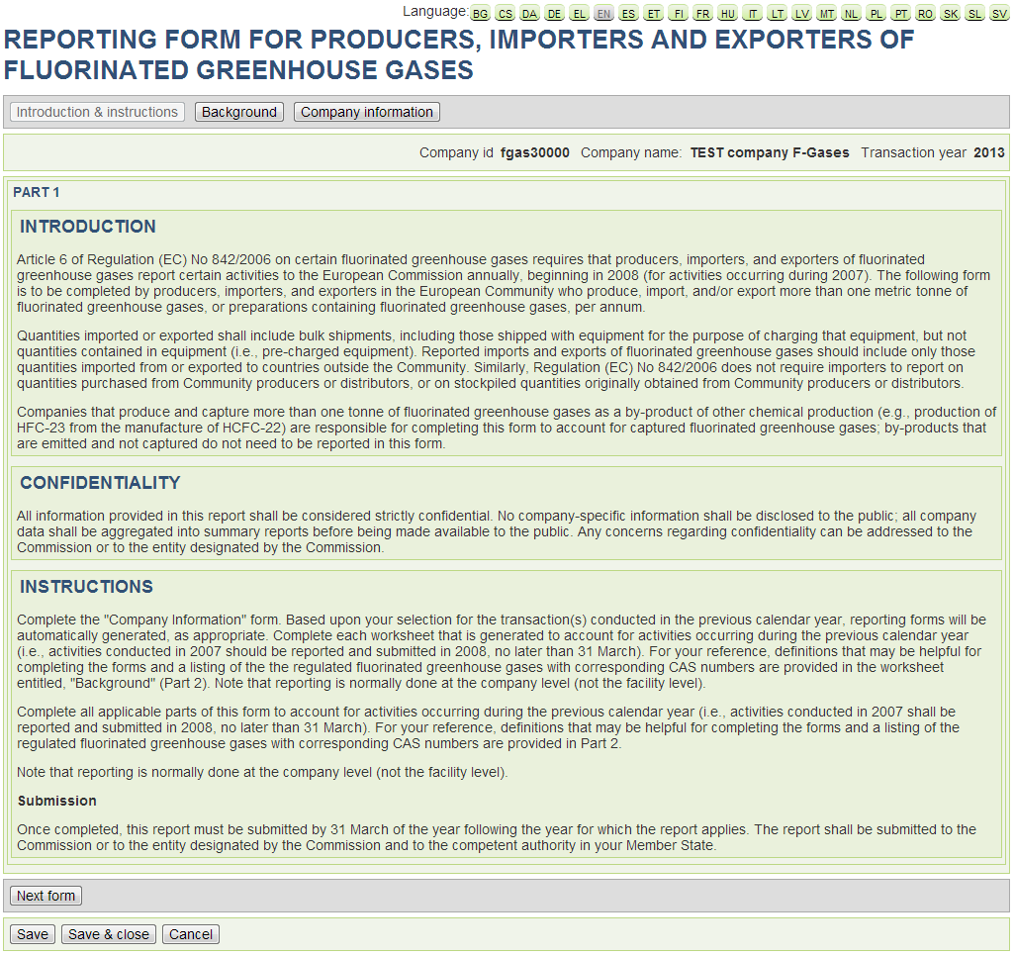

*‘Introduction & Instructions’ form – PART 1*

As part of the ‘Introduction’ info, you will also find the PART 2 form, in which the definitions and F-gases are provided, including the chemical formula and the CAS numbers.

### Step 2: Company contact information

In order to start reporting data you will need to confirm your ‘Company Contact Information’ in the next form (PART 3). You will then see the following screen:

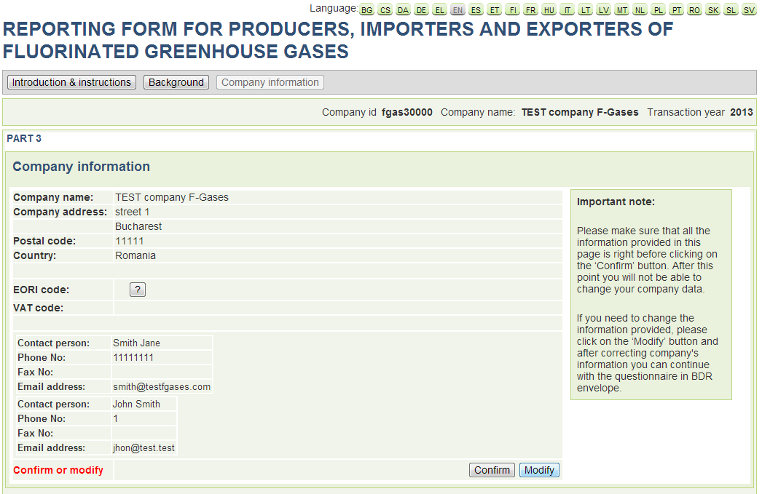

*‘Company contact information’ – PART 3 - Step1*

You can either ‘Confirm’ the information of your company or ‘Modify’ any details that you need to change. In the case you need to modify your data a message box will be prompt to inform you that you are about to leave the current webpage. After you do the necessary changes you can always come back to the questionnaire (button ‘Back to reporting’ on the top right corner and then re-choose the corresponding envelope) and confirm your company data.

**Please make sure that your company information is correct in this step, as you will not be able to change that after you start completing the questionnaire!**

### Step 3: Transaction year and choice of production/import/export activities for reporting

Once you confirm the contact data, you will be able to indicate the reporting year (‘transaction year’) and the type of activities per type of gases that have been performed by your undertaking during that year (see also next figure). Please note that following this step you will not be able to view all the tables described in the next pages. This is because the tables shown on the online questionnaire depend on the type of activities you report at this stage. All the relevant tables you will need to use will be however available.

Select activities in these cases:

* Production; if you produced more than one tonne of F-gases (HFCs/PFCs/SF6) in the transaction year;
* Import: if you imported into the EU more than one tonne of F-gases (HFCs/PFCs/SF6, including preparations containing F-gases) in the transaction year
* Export: if you exported from the EU more than one tonne of F-gases (HFCs/PFCs/SF6, including preparations containing F-gases) in the transaction year

If you are not obliged to report then choose the ‘Not obliged to report (NIL report)’ option. This is the case if you did neither produce more than one tonne nor import more than one tonne nor export more than one tonne of F-gases (including preparations containing f-gases) during the transaction year.

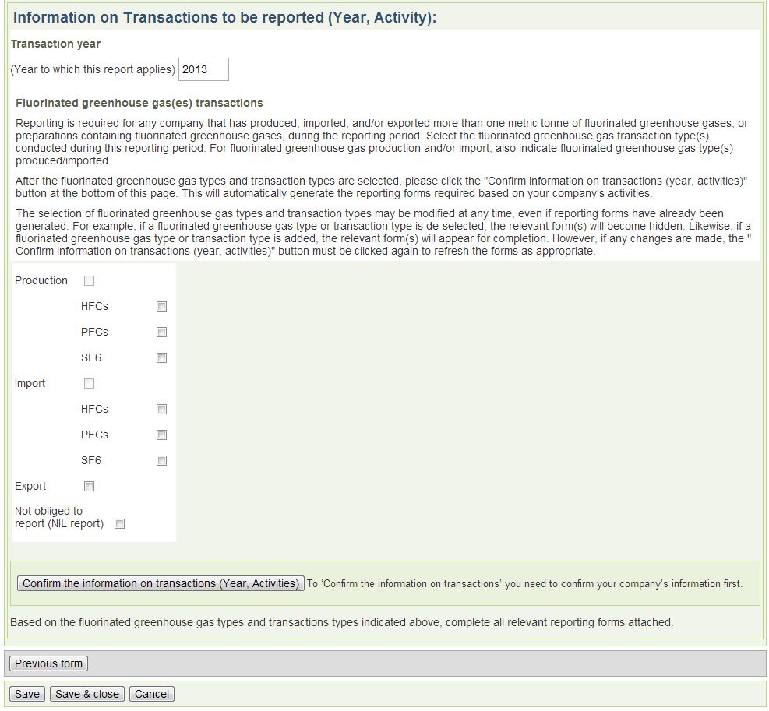

*‘Fluorinated greenhouse gas transaction(s)’ – PART 3 – Step2*

Once you have indicated the corresponding activities and gases you can move on to the reporting by clicking on the ‘Confirm the information on transactions (Year, Activities)’ button.

### Step 4: Select gases and preparations for reporting

In the next form you will need to provide the list of the fluorinated gases/preparations that you need to report. For choosing your gases or preparations you must first select the corresponding gases/preparations from the drop-down list and then use the ‘Add’ button. If you have mistakenly introduced a gas you can always remove it from your list once you click on the minus ‘-‘ button at the end of each row. At the moment, there are three lists available:

1. A HFCs list that includes the HFCs substances
2. A ‘HFC Preparations’ list that includes the blends with HFCs content and
3. A ‘PFCs/PFC Preparations’ list that includes both PFCs substances and blends with PFCs content.

Please note that in the case of preparations you may also use the ‘Define new preparation’ option in case you cannot find the exact blend your company has been importing/exporting/producing in the transaction year. In this case you will be asked to define the new preparation by describing its composition (mass percentages of blended gases). Note that in any case the percentages must add up to 100%. While selecting the components of the preparations you may also need to report ‘Other’ in the case that your blend includes a gas that is not a regulated F-gas.

You can define a new preparation under ‘HFCs Preparations’ or ‘PFCs/PFC Preparation’ groups. For preparations that contain both HFCs and PFCs, report quantities on either of these groups, but do not duplicate the information. You can later on report on the selected gases/preparations by using the respective forms for HFCs, HFCs Preparations and PFCs.

*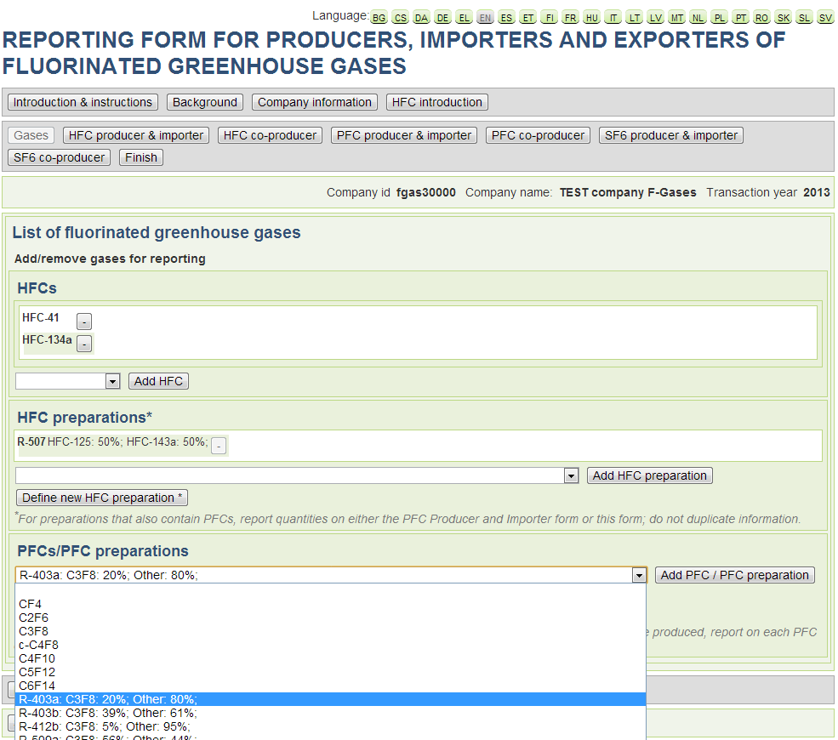‘List of Fluorinated Gases’ Form*

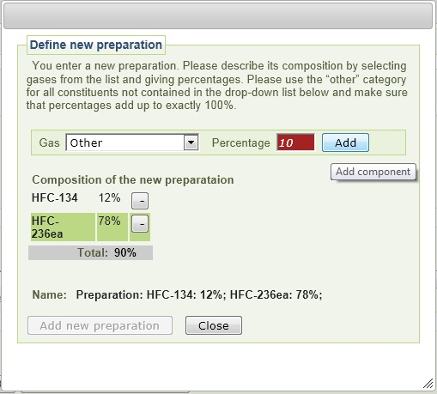

*Define new preparation dialogue*

Once you have selected all the gases/preparations you need to click on the ‘Next form’ button to carry on with the reporting.

### Step 5: Producer/Importer Forms for HFCs/PFCs/SF6

If you have indicated to be a HFCs producer or importer you will then see the ‘Producer and Importer Form 1 & 2: HFCs’.

***Please note that the guidance provided next for the filling of this forms is the same in case you are a PFCs or SF6 producer/importer. In order not to duplicate the same info in this annex, please also refer to the following paragraph if you need guidance on how to fill in the respective info for other gases.***

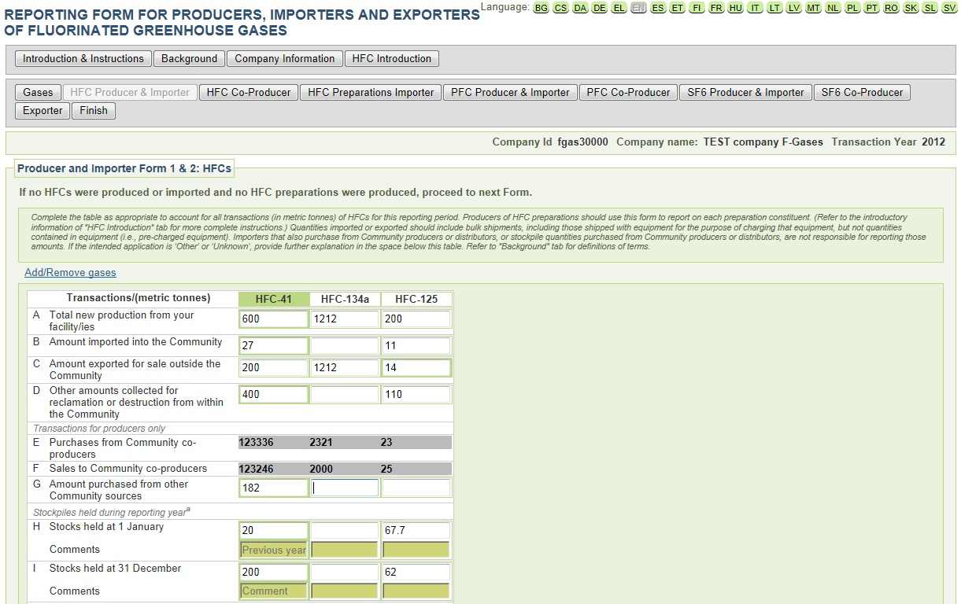*‘Producer and Importer Form 1 & 2:– Step 1*

In the first part of this report you need to indicate the gas quantities that your undertaking produced or imported / exported outside the EU. Here you can also indicate the amounts of gases you have collected for reclamation or destruction within the Community.

In the ‘transactions for producers only’ area the sales to/from Community’s co-producers and other community sources should be indicated. The grey cells are being automatically filled once you have entered data into the ‘Co-Producer’ form, therefore more information on how you can provide these details will be given in the following paragraphs. If you indicated to be only HFCs importer, then some of the producer specific cells are not relevant to fill in and they are not editable.

Finally the stockpiles held during the reporting year refer to the quantities held in the 1st of January and the 31st of December. Please note that the system will automatically detect any inconsistencies in the reporting with year X-1. In such cases a message box will automatically appear and you will be asked to provide a comment on the reasoning for this difference. In addition if the difference in the amounts reported in the beginning and the end of the year are high you will be also asked to provide a comment or correct your data.

*Please note that HFC stocks are differently defined for*

1. *HFC producers (which may import as well) and*
2. *HFC importers which did not produce HFCs:*

*(Definitions for PFC & SF6 producers/importers hold respectively.)*

***Producers*** *should report on full stockpiles irrespective of their origin.* ***Non-producing importers*** *should report only on stockpiled amounts which were previously imported into the EU by this company. Non-producing importers should not report on stockpiled amounts which were acquired on the EU market.*

You can also add a comment in the field under each relevant cell.

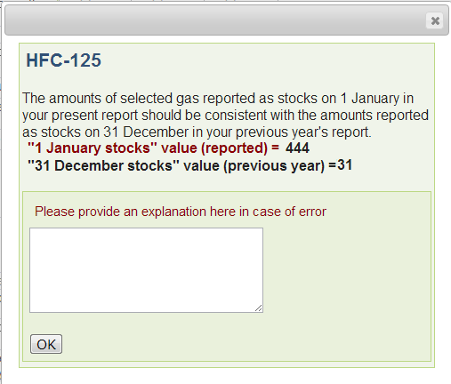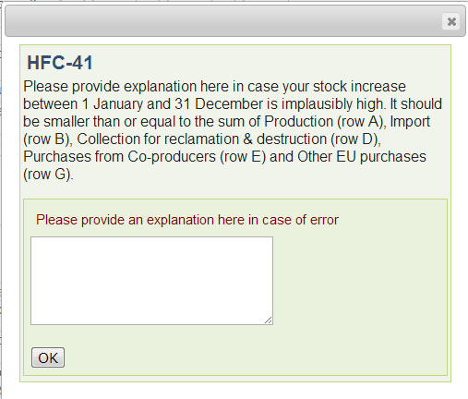

*Error messages indicating inconsistencies in the reporting*

In the second part of this form the reporter should indicate the quantities used for reclamation, destruction and feedstock. In the lower part of the form (rows O to U) the intended use of the gases should be stated. **Please note that the calculated totals reported in the upper part (line N) and in the lower part (Total amount placed on the market, line V) should match.** If you report on "other or unknown" intended applications. then please provide an explanation in the relevant comment box under the relevant cell.

All the information provided should be in metric tonnes. In case you want to delete the information you provided on one gas, you can use the ‘Clean’ button at the end of the respective column.

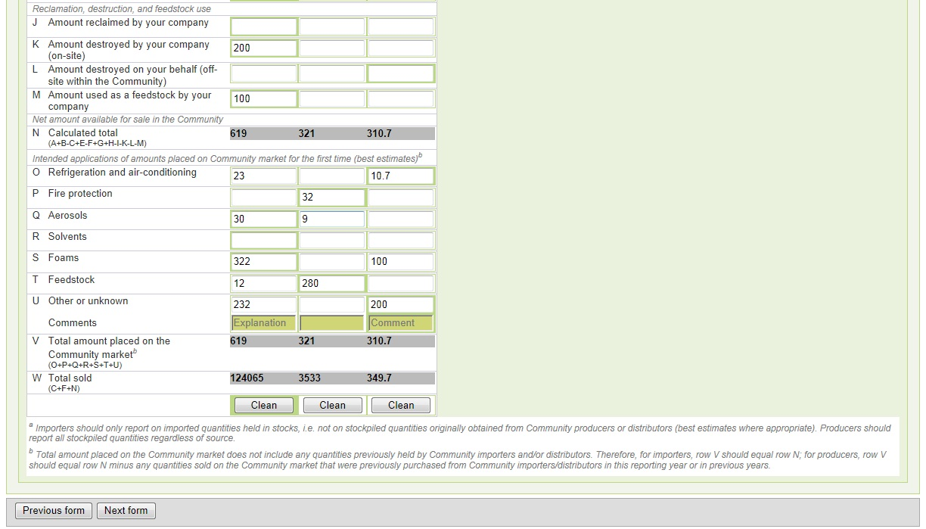

*Producer and Importer Form 1 & 2:– Step 2*

.

### Step 6: Co-Producer Forms for HFCs/PFCs/SF6

In case you are a producer you should indicate the purchases from and sales to Community Co-producers. In order to do so you have to click on the ‘Add Co-Producer’ button, fill in the name of the company and then click ‘Add’. Afterwards you must indicate the relevant quantities in the cells under each gas. If you want to delete a company you can always use the minus ‘-‘button to remove it from the list.

As before, the grey cells refer to the totals automatically calculated by the web form. Once you are satisfied with your contribution you may click on the ‘Next form’ button to continue with the reporting.

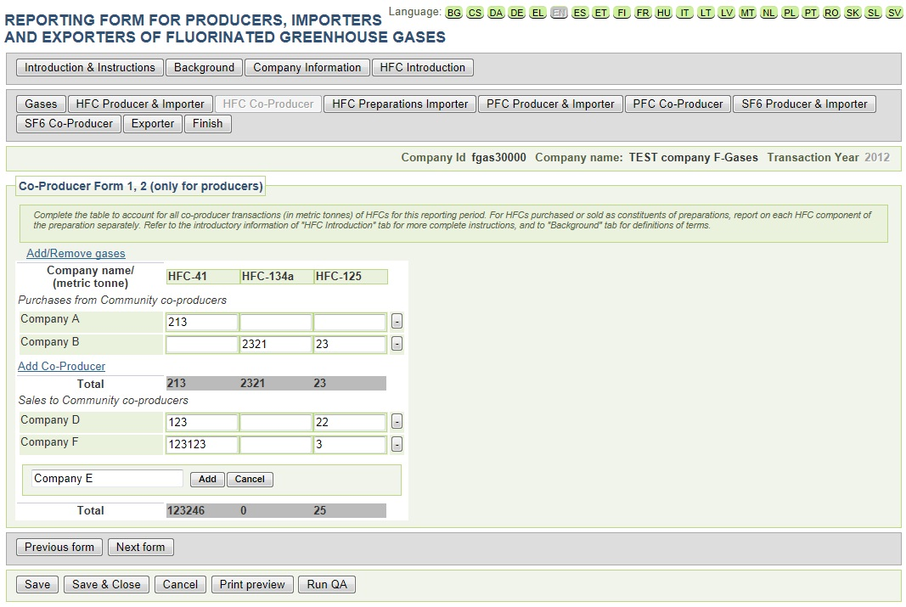*‘Co-Producer Form 1,2 (only for Producers’)*

***Please note that the guidance provided next for the filling of this forms is the same in case you are a PFCs or SF6 producer/importer. In order not to duplicate this info, please also refer to the following paragraph if you need guidance on how to fill in the respective info for other gases.***

### Step 7: HFC preparation importer form

The next form to be completed refers to the blends (preparations) that you may need to report (*Importer form 3: Preparations*). In the form the following quantities of blends should be indicated. The blends may include HFCs and/or PFCs.

* Quantities imported, exported or collected for reclamation/destruction within the Community
* Stocks held in the beginning (1st January) and end (31st December) of the reporting year
* Quantities referring to reclamation, destruction and feedstock use
* Quantities by intended application

Please note that, as indicated before, the system will automatically detect any inconsistencies in the reporting with year X-1. In this case you should provide an explanation for this difference in the ‘Comment’ area of the pop-up message box or correct your information. In addition **the amounts reported in row J (‘Calculated Total’) should equal the amount in row R (‘Total amount placed on the Community market’)**.

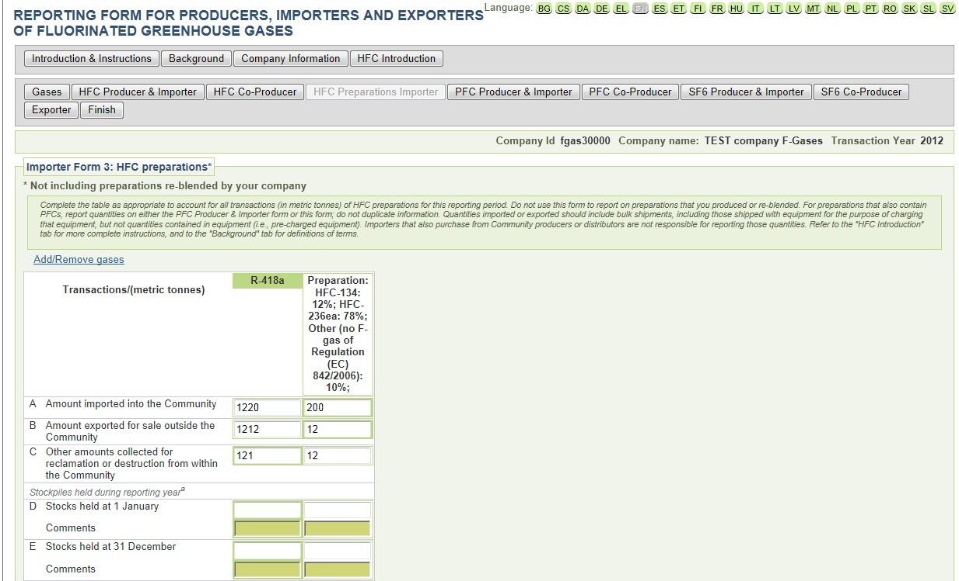*Importer Form 3 – Step 1*

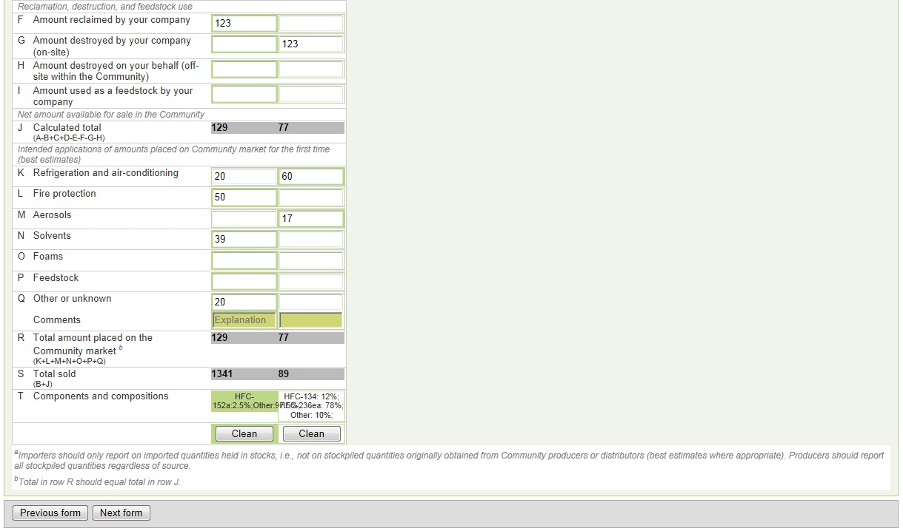*Importer Form 3 – Step 2*

Once you have filled in all the required information for this form you can continue with the reporting for Importers/Producers for PFCs and SF6, as appropriate, depending on the activities you have indicated at the beginning of the reporting process.

### Step 8: Exporter form

After completing the above-mentioned reporting for other gases, you will be asked to fill in the Exporter information (provided that you have indicated that you are an Exporter):

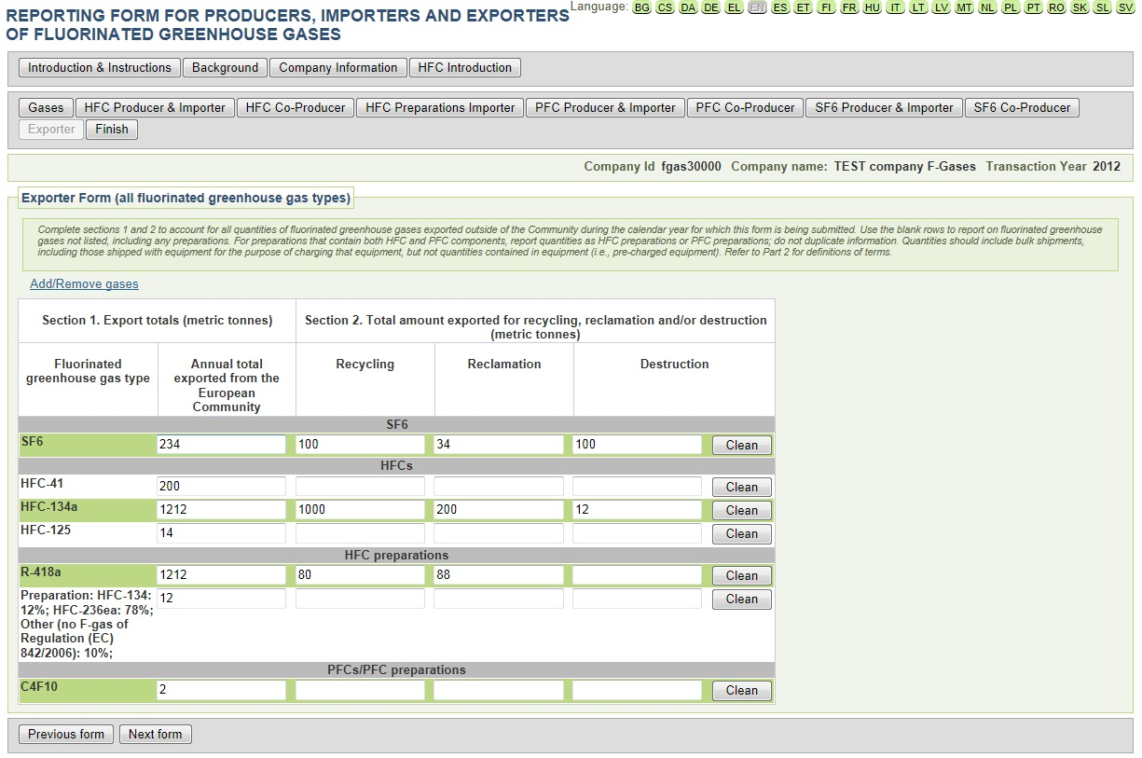*Exporter form (all fluorinated greenhouse gas types)*

In this form you must indicated the annual amount exported from the EU by your undertaking, indicating also the quantity intended to be recycled, reclaimed or destructed (whenever relevant). The ‘Clean’ button can be used in the case you want to clear the content of the row.

**Please make sure that the amounts reported as ‘Annual total exported’ in the ‘Exporter form’ equal the amount reported as exported in the respective ‘Producer/Importer form’ (in case you did produce or import).**

### Step 9: Quality control, certification and finish

Once you are finished with all previous forms, you will have completed the main part of your reporting. By clicking ‘next form’ you will be asked to certify the correctness of the reported data.

**Before doing so we strongly recommend to check the consistency of your reported data by pressing the ‘Run QA’ button.** This will trigger a series of automated quality checks, the same set of checks that will be later used to test your report on submission. The test result will open in a new window/tab of your browser. For a description of the system of ‘Blocking errors’ and ‘Potential errors’, please refer to the main body of the BDR guidance (there: Step 5: Check quality of reported data). In case of blocking errors, you must adjust your data in order to safeguard a successful submission later-on. In case of ‘warning errors’ you are invited to check whether you are confident that your data is correct. ‘Warning errors’ will not prevent a successful submission of your report

**In order to finalise the questionnaire, you have to certify therefore that you are an authorized representative of the undertaking and that all the submitted information is true, accurate and complete (to your knowledge):**

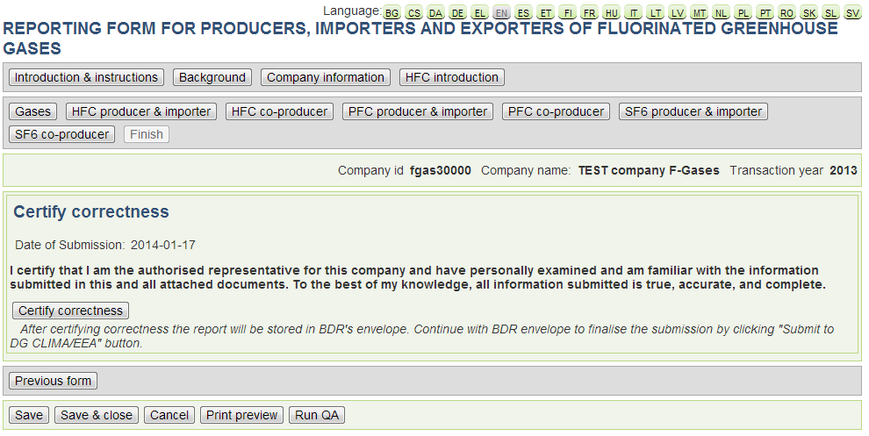

*‘Certify Correctness’ form*

After this step you will have concluded the questionnaire and you will see the following form, where you can click on the ‘Print Preview’ button to view the summarized information you are about to submit or on the ‘Run QA’ button in order to assess the quality of your report before submitting.

*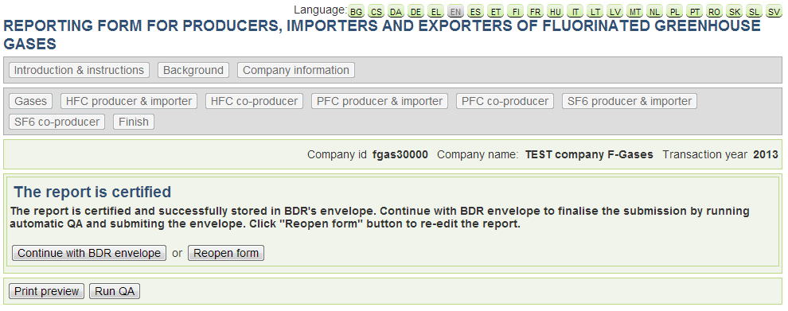Finalization of the Questionnaire*

If you are ready to submit then click on ‘Continue with the BDR envelope’ in order to continue with submitting the envelope to DG CLIMA/EEA. In this case, please refer to the main manual for more guidance on how to submit using the BDR system.

You may also choose to re-open the form in order to review/modify the data you have reported in the previous steps.